Data Center Temperature Monitoring Dashboard, here are some popular temperature monitoring systems and manufacturers:
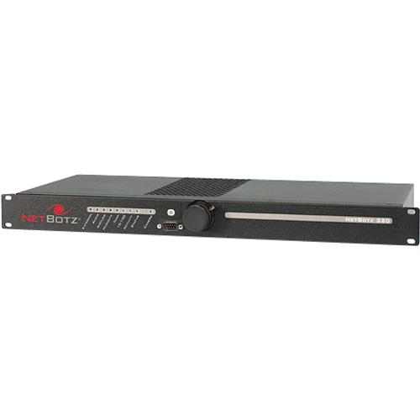
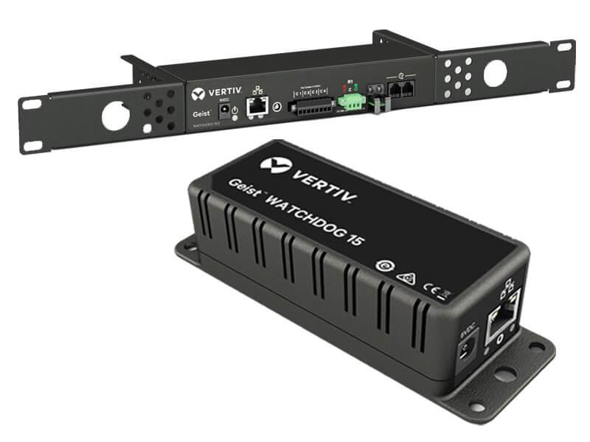
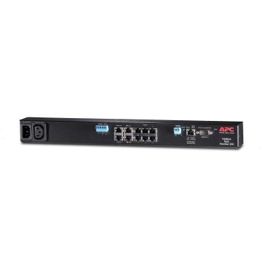

Recommended Data Center Temperature Monitoring Solutions
Company | Product | Use Case
Schneider Electric | NetBotz | Temperature, humidity, and rack monitoring
Vertiv | Geist Environmental Monitoring | Data center environmental monitoring
APC | APC NetBotz | Server room temperature monitoring
Raritan | Environmental Sensors | Temperature and humidity alerts

Dashboard Format in Excel
Location | Temperature (°C) | Humidity (%) | Status
Server Room 1 | 22 | 45 | Normal
Server Room 2 | 25 | 50 | Normal
UPS Room | 29 | 60 | Warning
Network Room | 31 | 65 | Critical

Status Colors
- 🟢 Normal: 18–27°C
- 🟡 Warning: 28–30°C
- 🔴 Critical: Above 30°C
For your IT dashboard, you can create KPI cards such as:
- Current Temperature
- Average Temperature
- Highest Temperature
- Active Alerts
- Humidity Level

